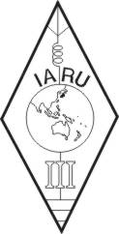 | INTERNATIONAL AMATEUR RADIO UNION  REGION 3  SIXTEENTH REGIONAL CONFERENCE | 
12 – 16 October 2015 Bali, Indonesia

Document No. 15/XVI/053
Agenda Item: 11.5

PROPOSAL FROM CRSA/CRAC
MODIFICATION TO THE IARU REGION 3 BAND PLAN

The Chinese Radio Amateurs Club
The Chinese Radio Sports Association

Background/reason:
There is significant uptrend in the operation of small amateur satellite world-widely, the frequency harmonization between three IARU regions appears more essential. The IARU regional band plans will be the fundamental reference for amateur satellite designers.

Considering:
a) In the IARU Region 3 Band Plan (2009) the portion of 145.8-146MHz in the 144MHz chart is identified as for Satellite while some rest portions are not identified, which left certain ambiguity for interpretation;

b) The 430MHz and 1,240MHz chart have the similar undefined portions.

Proposal:
To add a note below the 1240MHz chart as shown in the annex.

Annex

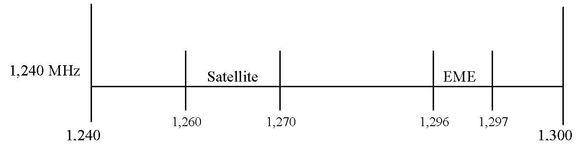
Note: The unidentified portions in the 144, 430 and 1,240MHz charts are exclusively for the applications other than EME or Satellite.





